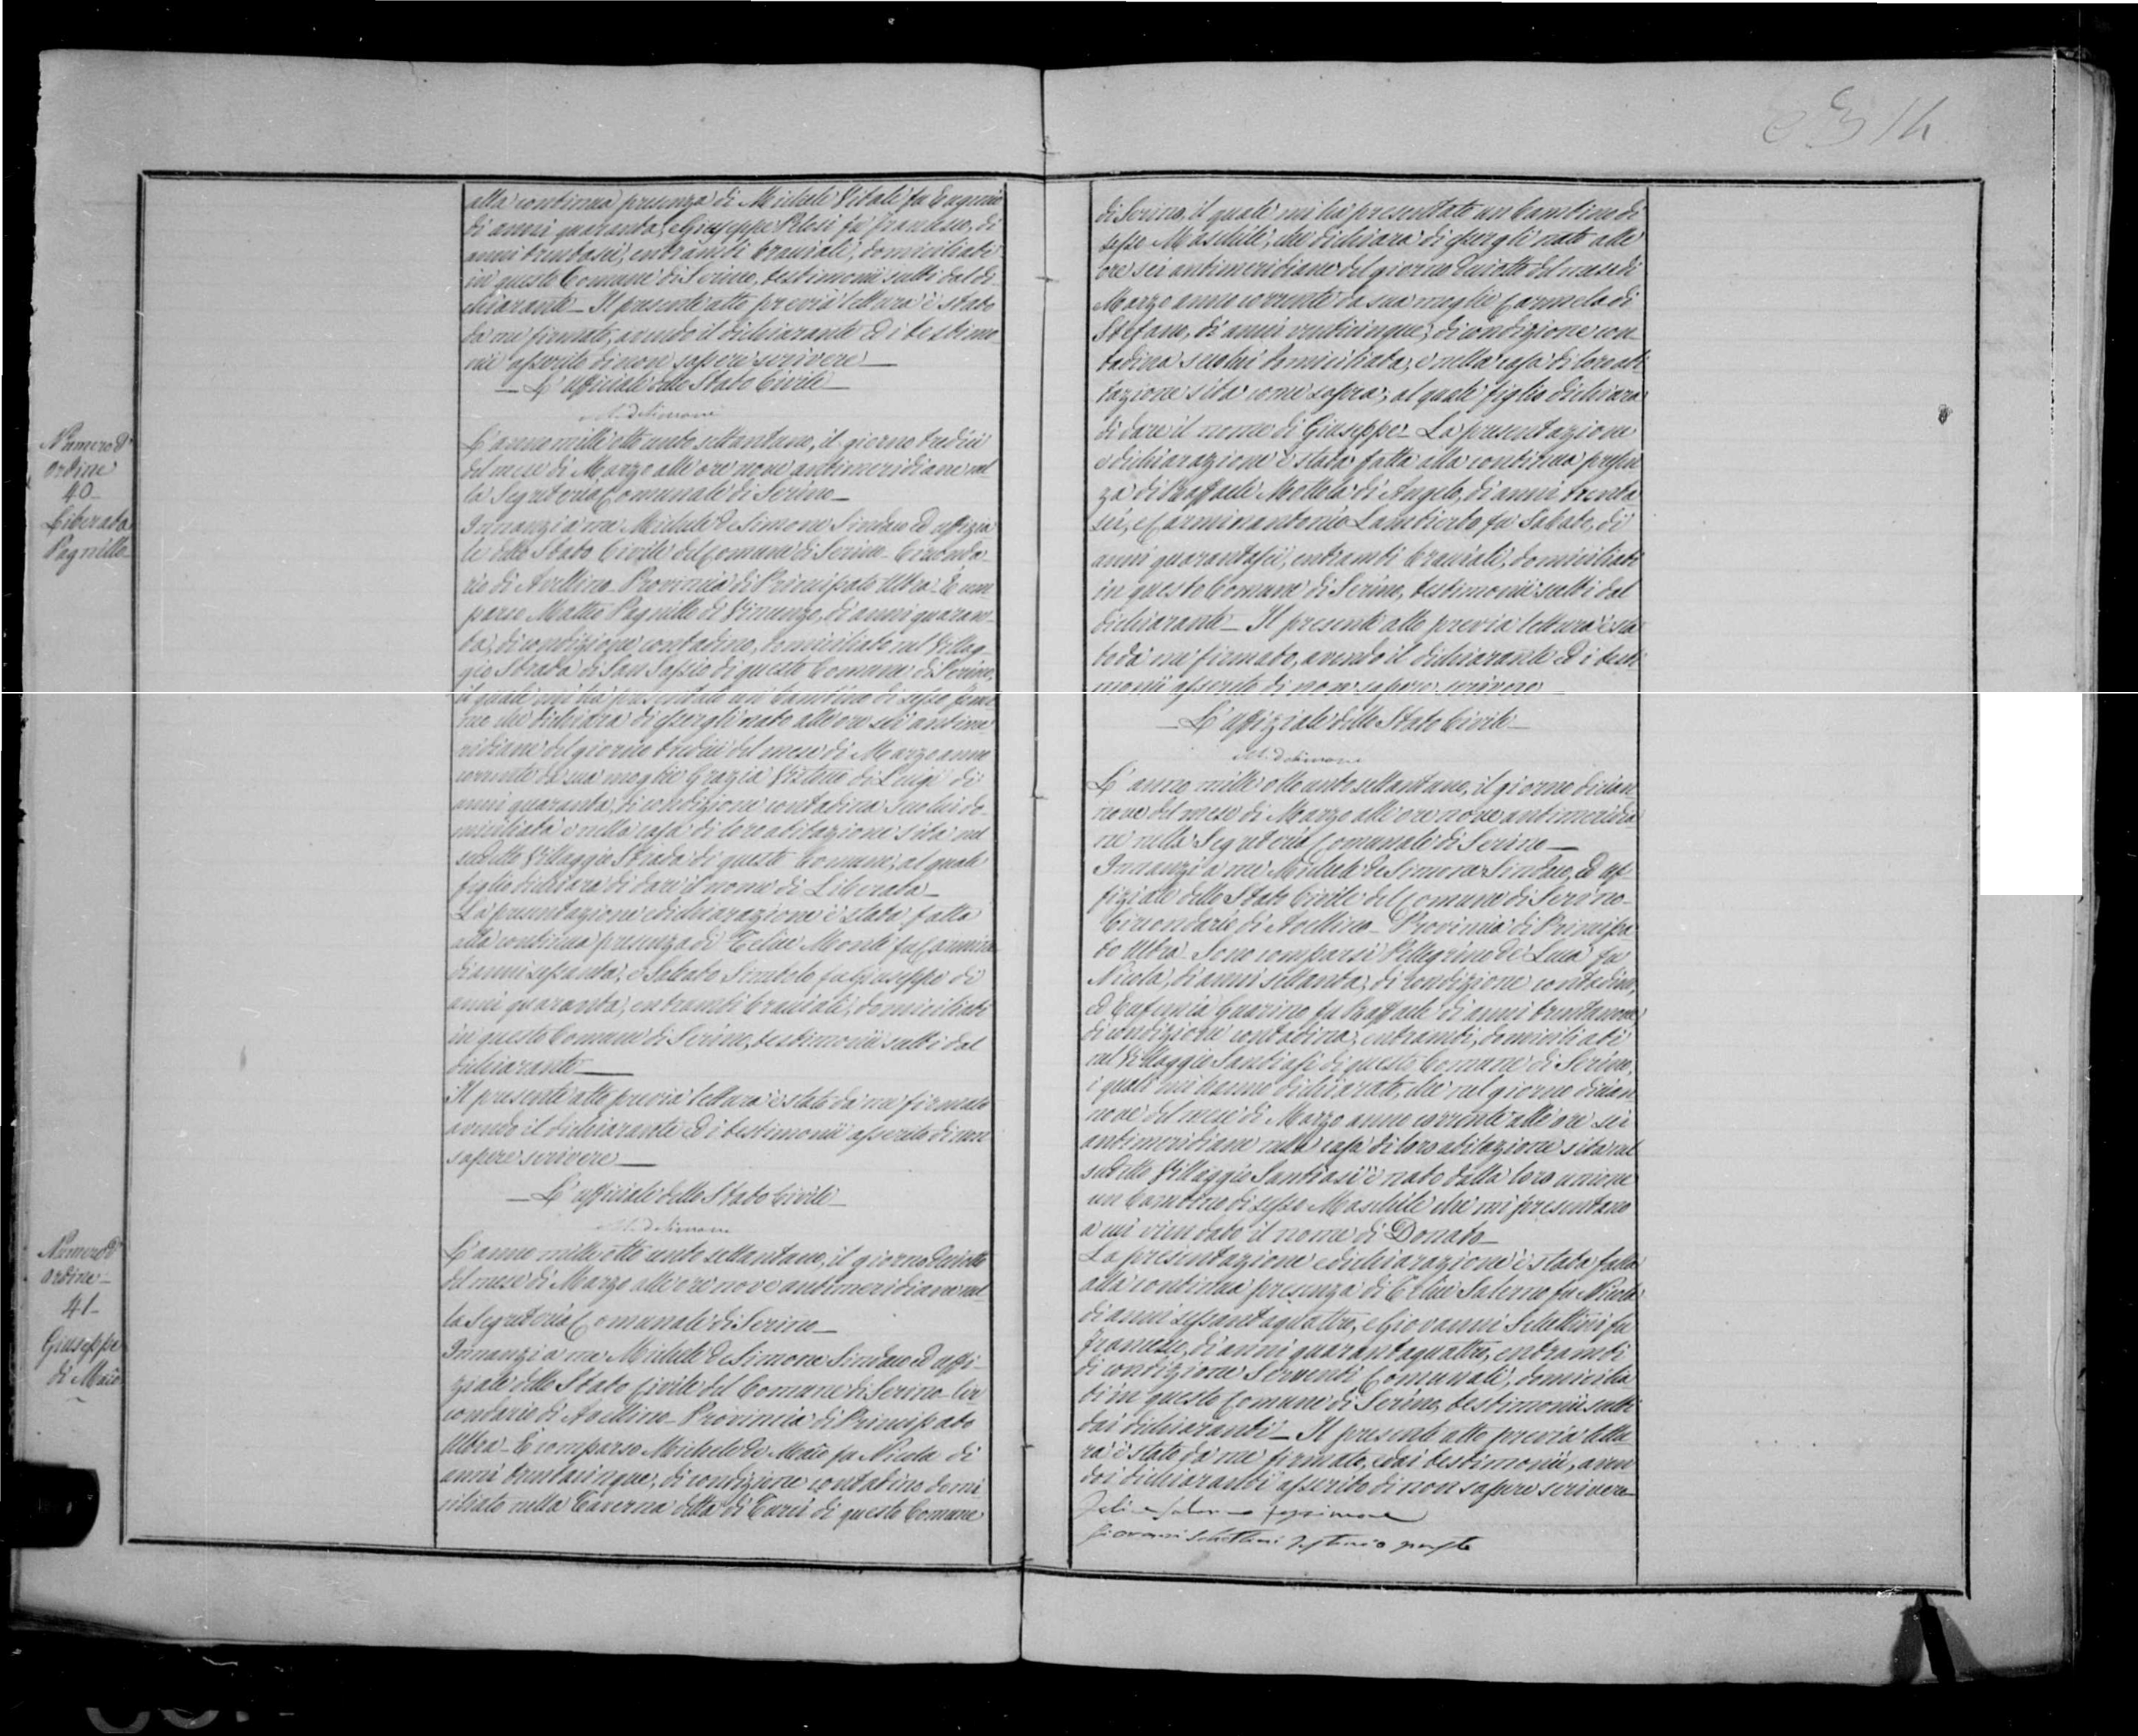

41/.... ;,
; ,, ./(
Y//_..ç·
{('

